Curriculum Network Analysis of Quantitative Bottlenecks in
Hospitality Management Education (Paper #445)

Larissa Mae Maranan-Montano
Department of Hotel, Restaurant and Institution Management & Data Science Program
University of the Philippines Diliman

Giovanni A. Tapang
National Institute of Physics & Data Science Program
University of the Philippines Diliman

Abstract:
This study uses a dual-network analysis to evaluate student progression in a rapidly growing hospitality bachelor’s program. The program has expanded by 64% since 2024, yet the 2021 curricular revision has produced an on-time graduation rate of only 24%. To identify the systemic drivers of this delay, the curriculum is modeled through two distinct lenses: a structural curriculum network based on official prerequisites and an empirical progression network derived from the records of N=269 students. Structural analysis reveals a high-risk prerequisite chain centered on the subjects of calculus (CALC) and statistics (STAT), with the operations management (ORM) subject serving as the main structural chokepoint (betweenness centrality = 0.0335). Louvain community detection confirms strong structural partitioning (modularity Q = 0.674) that degrades sharply in the empirical network (Q = 0.231), where failure and retake cycles blur intended prerequisite tiers. CALC emerges as the dominant academic bottleneck, with a 37.3% failure rate, 295 total attempts from 194 unique students, and a self-loop weight of 71, confirming mandatory failure-driven retakes. The dominant empirical hub by degree is PHYSED2, a structural artifact of its four-time enrollment requirement. These findings support targeted early intervention in quantitative courses and curriculum revisions that reduce reliance on a single prerequisite chain. In this program, 76% of students did not graduate on time under the revised curriculum, even though some may eventually complete it.

Keywords: hospitality education, curriculum network, curriculum roadblocks

1. Introduction
In this paper, we discuss a bachelor’s program in hospitality management at a local university that has experienced unprecedented growth. Between 2023 and 2025, new cohorts have grown to represent over 60% of total enrollment, with section counts escalating from a single section in 2021 to four sections by 2025. However, this growth has collided with the structural rigidities of the 156-unit curriculum revised in 2021. Preliminary data from the inaugural 2021 cohort reveal a concerning trend: only 24% graduated on time. On-time graduation means completing all 156 required units within eight regular semesters (four academic years), excluding midyear terms. The remaining 76% have either withdrawn or faced significant delays.

The primary driver of delays is the prerequisite trap centered on core quantitative and professional courses. The progression into the culinary management (CUL) series, a critical fifth-semester block that must be taken in its entirety, requires successful completion of operations management (ORM). ORM requires CALC and STAT. High failure rates in these foundational subjects have created a massive backlog. The department has offered ORM every semester since 2022 to accommodate students who have been delayed by one to five semesters.

This off-season scheduling places an unsustainable strain on limited faculty and classroom resources. With the population nearly quadrupling in four years, the department faces a dual crisis: maintaining academic rigor while ensuring student flow through a curriculum that currently lacks the flexibility to absorb failure or delay. There is an urgent need to shift from anecdotal observations to data-driven modeling to understand how these prerequisite chains impact student momentum.

Research Objectives
This study seeks to provide a quantitative framework for curriculum management by pursuing the following objectives:
- Map the given hospitality curriculum as an empirical progression network to visualize student flow.
- Identify specific bottleneck nodes that disproportionately hinder on-time graduation.
- Quantify the impact of failure rates on institutional resources and student progress.

2. Literature Review

2.1. Structural Complexity and Curricular Analytics
Network analysis is widely used across fields to study complex systems by modeling entities as nodes and their relationships as links (Roxas, 2010). Modern curricular assessment has shifted from subjective evaluation toward curricular analytics, which models degree programs as directed curriculum networks. Within this framework, courses are treated as nodes and prerequisites as directed edges. Aldrich (2015) provided an early formal treatment by modeling the undergraduate curriculum at Benedictine University as a Course Prerequisite Network (CPN), revealing hidden community clusters, bridges, and hub courses not apparent from the catalog alone. Structural complexity in CPNs is defined by three key metrics: the blocking factor (courses blocked by a single failure), the delay factor (the longest prerequisite chain through a course), and centrality (Slim et al., 2014; Heileman et al., 2019). High structural complexity often correlates with higher failure rates and elongated time-to-degree, particularly in professional programs where foundational quantitative sequences act as gatekeepers with high blocking factors.

Yang et al. (2024) provide the most comprehensive peer-reviewed CPN application across public universities. They formally define the CPN as G = (V, E) and apply centrality measures—betweenness centrality, out-degree, reach, and transpose PageRank—to the CPNs of six American institutions. Their reach(v) metric quantifies the total downstream courses for which course v is a direct or indirect prerequisite. Their findings confirm that mathematics courses achieve the highest betweenness centrality and reach values across all institutions studied, establishing mathematics prerequisites as a structural feature of STEM-adjacent curricula rather than an institutional anomaly. Yang et al. further introduce the Longest Paths Induced sub-Graph (LPIG), the subgraph containing all courses on prerequisite chains of length ≥ k, as a formal construct for identifying the most highly constrained degree pathways.

Zuev & Stavrinides (2025) introduce three global CPN measures—breadth (B), depth (D), and flux (Φ)—grounded in topological stratification, enabling whole-curriculum diagnosis beyond node-level properties. Basavaraj et al. (2022) combined Sankey visualizations with network science curricular analytics to map degree mobility patterns, finding that foundational course performance is the primary driver of differences in progression across cohorts. This body of work establishes that the network-analytic approach is not merely descriptive but diagnostic: the structural position of a course in the CPN predicts its real-world impact on student progression and time-to-degree.

2.2. Learning Analytics and Student Progression
Learning analytics (LA) measures and reports data on learners and their contexts to understand and optimize learning and the environments in which it occurs (Conijn et al., 2017). Rienties & Toetenel (2016) studied 151 modules and 111,256 students at the UK Open University, finding that the structural design of a course strongly predicts student engagement, retention, and satisfaction. This parallels the rationale for applying network-level curriculum metrics: both approaches treat program structure as a tractable, data-measurable driver of student outcomes rather than as a fixed condition.

Predictive modeling has extended this to identifying at-risk individuals. Conijn et al. (2017) compared 17 blended courses at a Dutch university and demonstrated that LMS engagement data can accurately predict final course grades, enabling intervention before failure becomes irreversible. For structured prerequisite programs like the hospitality curriculum, this has significant implications: early engagement predicts course-level outcomes, and course-level outcomes in prerequisite-gating courses predict degree-level trajectories. Identifying bottleneck courses through network analysis is a critical first step in at-risk identification pipelines.

In the Philippine higher education context, these issues carry particular urgency. The Commission on Higher Education (CHED) updates its Policies, Standards, and Guidelines (PSGs) on average every 11 years (EDCOM II, 2023). Structural curricular problems identified today may persist for nearly a decade before the next revision window. This institutional inertia makes data-driven, within-cycle evidence especially valuable. Curriculum network analysis provides precisely this type of evidence, allowing programs to optimize student outcomes without waiting for a full curriculum overhaul.

2.3. The Hospitality Curriculum
Quantitative subjects such as calculus and statistics have long been integrated into hospitality curricula (Cullen & Lambert, 1987). For example, Cullen and Lambert (1987) report that leading U.S. hospitality programs typically require at least one semester of business statistics and one analytics-oriented course. More recently, Fei et al. (2025) highlight modules on revenue management, demand forecasting, and data-driven pricing as standard quantitative components in contemporary hospitality degrees.

Regional comparisons of hospitality programs in Asia reveal that curricula frequently struggle to balance business-theoretical foundations with specialized practical training (Wang & Abukhalifeh, 2021). Fei et al. (2025) recommend that future curricular revisions prioritize immersive industry-based learning, hospitality-specific technologies such as CRM systems and online reservation platforms, and a heightened focus on big data and analytics.

Notably, the ASEAN Common Competency Standards for Tourism Professionals (ACCSTP) and the Common ASEAN Tourism Curriculum (CATC) do not list quantitative analytics, statistics, or calculus as explicit competency domains. The heavy quantitative prerequisite chain in the hospitality curriculum under consideration (PRECALC → CALC → STAT → ORM) is therefore a feature of CHED’s academic degree framework, not a requirement of the ACCSTP vocational competency standards. This structural tension between academic gating logic and the industry-facing competency framework governing regional workforce mobility is a key contextual factor in the present analysis.

2.4. Research Gap
Curriculum network analysis literature is growing, but applications to hospitality management programs remain scarce. Existing CPN studies have focused on STEM, computing, and general undergraduate programs at North American and European institutions (Aldrich, 2015; Yang et al., 2024). The structural dynamics of professional service-sector curricula—which combine quantitative requirements with practicum-heavy experiential sequences—remain unexamined.

Philippine hospitality programs face additional complexity. The said hospitality program is governed by CHED’s PSG framework, operates under AUN-QA accreditation standards, and has undergone rapid enrollment expansion in the post-pandemic period. These conditions allow structural prerequisite bottlenecks to compound quickly across large cohorts. The present study fills this gap by applying a dual-network curriculum analysis that combines a structural blueprint with empirical student flow—the first network-analytic bottleneck assessment of a hospitality management curriculum in the ASEAN region.

3. Methodology
This study employs a dual-network analysis approach to evaluate the hospitality program. Both networks share the same node set of courses. However, they encode different edge types. The structural network uses prerequisites from the official curriculum document. The empirical network uses observed student transitions from enrollment records. We developed two distinct models. The Structural Curriculum Network maps the program's theoretical design. The Empirical Progression Network analyzes the actual movement of N = 269 students.

3.1. Structural Curriculum Network
The initial phase involved modeling the formal 156-unit hospitality curriculum as a directed graph to quantify its inherent complexity. Following Yang et al. (2024), the curriculum is formally encoded as a CPN G = (V, E). Graph-theoretic centrality measures identify courses of structural importance, including betweenness centrality and node reach. Following Zuev & Stavrinides (2025), a transitive reduction was applied to remove any edge i → k where a longer directed path i → … → k already exists, ensuring that computed centrality values reflect only essential prerequisite structure.

Nodes represent each unique subject in the 156-unit program. Directed edges link prerequisite subjects to their subsequent target courses. Prerequisite edges were assigned a weight of w = 2, reflecting a hard sequential dependency in which failure fully blocks access. Corequisite edges were assigned w = 1, reflecting softer coupling, allowing concurrent enrollment. To assess sensitivity, all centrality measures reported in §4.1 were recomputed under uniform weighting (w = 1 for all edges). The top-five betweenness and reach rankings were unchanged, confirming that structural bottleneck identification is robust to the weighting scheme.

Co-requisites are treated as unidirectional edges from the first-offered term to the co-offered course. Retake loops in the empirical flow are represented as parallel paths rather than back-edges. This preserves the acyclicity of the directed curriculum network.

3.2. Empirical Progression Network
The second phase modeled students' actual academic histories to identify deviations from the theoretical blueprint. We extracted and anonymized the curriculum checklists of N = 269 students currently enrolled under the current curriculum (covering the 2021–2025 cohorts). Unlike the static structural network, this model maps the subjects students actually took sequentially, including retakes and off-season enrollments. Each node was enriched with performance data, including total attempts, failure rate (f), and counts of incomplete (INC) or dropped (DRP) attempts. Edges were weighted by transition frequency—the volume of student flow between subjects across all recorded semesters.

This phase follows the analytical pipeline established by Basavaraj et al. (2022), who extracted term-by-term institutional enrollment records for student cohorts and overlaid them on a curricular network representation to identify which courses generated the greatest disruptions in student degree mobility. Their approach of coupling historical student-flow data with network analysis to “provide recommendations to improve student outcomes” (Basavaraj et al., 2022, p. 791) directly informs the construction of the empirical progression network in the present study.

3.3. Visualization and Comparative Analysis
Both networks were constructed and analyzed using the Python NetworkX library (Hagberg et al., 2008). The structural network was rendered using a hierarchical layout ordered by topological level—entry-point courses with no prerequisites at the top, deeper prerequisite levels descending—to make prerequisite flow visually explicit. The empirical network was rendered using the ForceAtlas2 force-directed algorithm (Jacomy et al., 2014), which positions high-degree hub nodes centrally and clusters tightly connected courses together.
This approach follows Yang et al. (2024), who similarly employed Gephi alongside NetworkX to compute and visualize betweenness centrality distributions and modularity-based clustering. Community detection was performed using the Louvain algorithm (Blondel et al., 2008), and modularity scores (Newman & Girvan, 2004) were computed for both networks.

The structural integrity and friction of the program were evaluated by comparing the two networks through three primary lenses: in-degree and out-degree distributions, to identify gateway and bottleneck courses where student flow stalls; transition density, to quantify the velocity of student movement through high-stakes blocks like the CUL series; and path deviation, comparing theoretical network diameter against the actual multi-attempt paths taken by students to identify systemic delays.

4. Results

4.1. Structural Curriculum Network Analysis
The visualization reveals a highly centralized network architecture with a clear prerequisite backbone. The following are the key structural features of the curriculum.

4.1.1. High-risk Prerequisite Chain
In Figure 1, the red cluster constitutes the highest-risk prerequisite sequence in the structural network. This path is a single-file line starting with PRECALC (pre-calculus mathematics), a non-credit bridging course that is a prerequisite for CALC. STAT and CALC are prerequisites for ORM, which is the gateway to the CUL (culinary) series. Failure at any node in this sequence blocks all downstream progression. Academic advisers encourage students to attempt CALC and STAT during their first year to minimize cumulative delay.

Figure 1.
Structural Curriculum Network of the Hospitality Program (156 units)
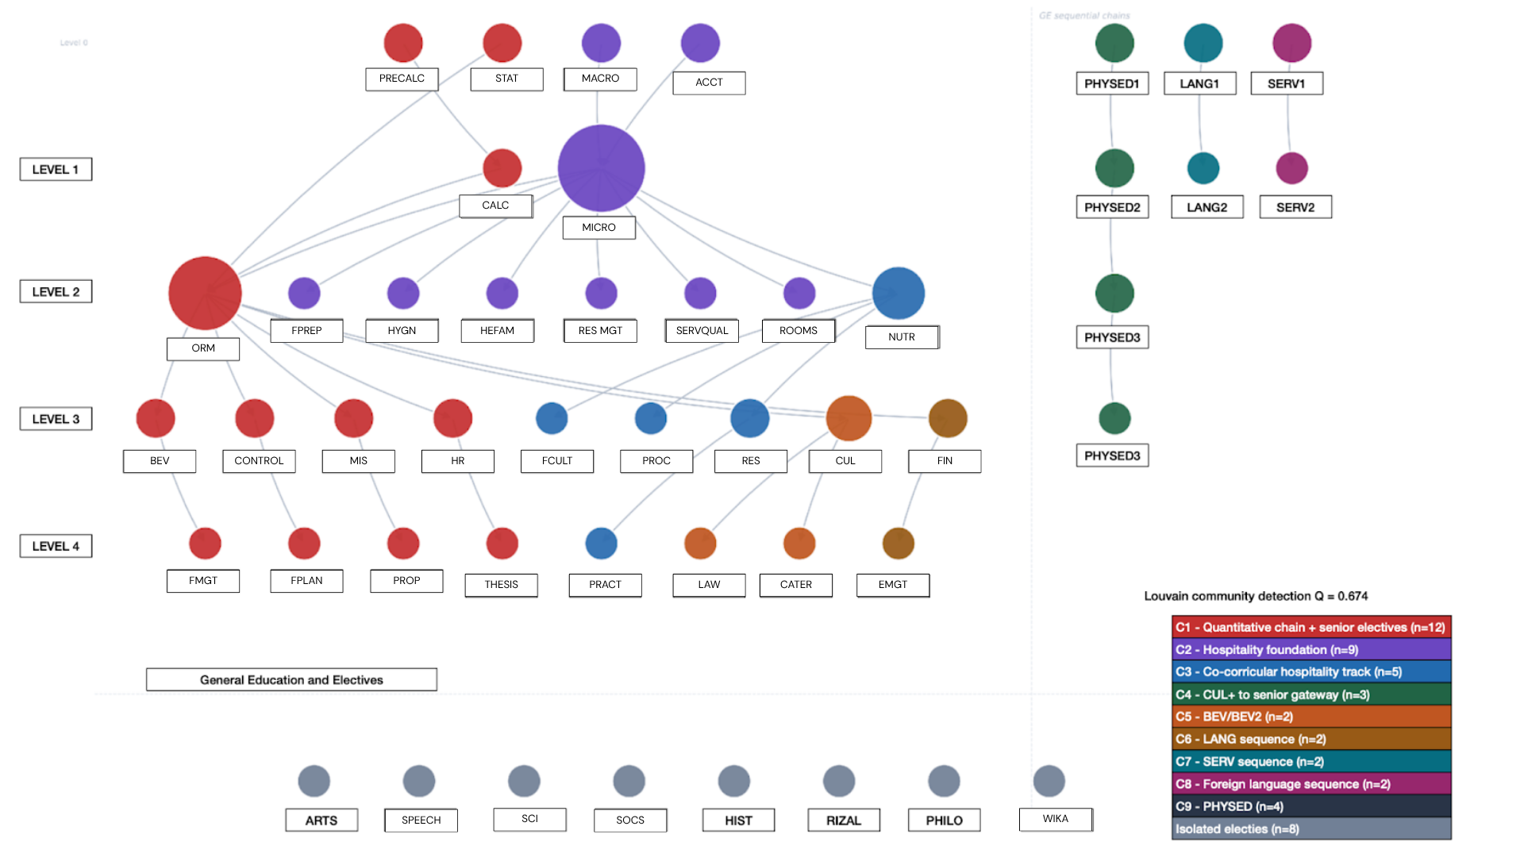
Note. Nodes represent individual courses; directed edges point from prerequisite to dependent course. Node color encodes Louvain community membership (modularity Q = 0.674; red = quantitative chain community, purple = hospitality foundational cluster, gray = general education (GE) and other clusters). Node size is proportional to out-degree. Key bottleneck courses (CALC, STAT, MICRO, ORM) are labeled in the figure.

4.1.2. Hub Dominance
Two major high-degree star subgraphs are evident: MICRO (micro-perspectives in hospitality, generally taken during the first two years) and CUL/RES (research, junior courses). MICRO has a massive out-degree, serving as the prerequisite for at least seven core courses. CUL and RES act as gatekeepers to senior courses with high betweenness centrality. Congestion at either node constrains the entire graduation pipeline.

4.1.3. Structural Asymmetry
The early clusters are broad but shallow; the later clusters are deep with many successive prerequisites. In the framework of Zuev & Stavrinides (2025), this asymmetry is formally captured by topological stratification: the early strata S₁–S₂ are wide (high breadth, many courses per stratum), while the later strata leading to the CUL and LAW series are narrow, producing a high-depth, low-breadth terminal structure. A curriculum with this profile has the longest path relative to its total node count—precisely the structural condition that Zuev & Stavrinides identify as associated with constrained degree programs and extended time-to-graduation. The “high-risk chain of survival” corresponds to the long-path subgraph that would dominate the hospitality LPIG, confirming the linear quantitative prerequisite chain as a systemic architectural feature.

4.1.4. Community Structure
Louvain community detection yields nine communities at Q = 0.674, well above the threshold for meaningful community structure (Q > 0.30; Newman & Girvan, 2004). The largest community (C1, 12 courses) groups PRECALC, CALC, STAT, and ORM (operations management) with their downstream senior electives, confirming this chain as a single structurally cohesive unit. C2 (9 courses) captures the hospitality foundation cluster anchored by MICRO, encompassing all seven courses directly unlocked by MICRO, as well as its two prerequisite feeders (MACRO, or macro-perspectives in hospitality, and ACCT, or accounting management). Smaller communities correspond to the PE series, English composition, SERV (service training program), and foreign language elective pairs. The high modularity reinforces structural asymmetry: the curriculum is a set of largely separate prerequisite sub-chains converging at two chokepoints, MICRO and ORM, before diverging again into the senior tier.

4.1.5. Structural Network Centrality Measures
Table 1 reports six graph-theoretic metrics for key curriculum nodes (Yang et al., 2024; Zuev & Stavrinides, 2025). In-degree counts prerequisites; out-degree counts courses directly unlocked; betweenness centrality measures the proportion of shortest paths passing through a node; reach quantifies the total downstream courses; delay factor measures the longest prerequisite chain from a node; and blocking factor counts courses immediately inaccessible upon failure. The values in Table 1 include all downstream courses in the curriculum, including both hospitality and non-hospitality subjects, which explains why MICRO’s reach (26) exceeds CALC’s (17).

Table 1.
Structural Centrality Measures— Key Hospitality Curriculum Nodes
Course | In-deg | Out-deg | Betweenness | Reach | Block. F. | Delay F.
ORM | 3 | 6 | 0.0335 | 16 | 6 | 3
MICRO | 2 | 8 | 0.0182 | 26 | 8 | 4
CUL | 1 | 2 | 0.0098 | 4 | 2 | 2
CALC | 1 | 1 | 0.0059 | 17 | 1 | 4
RES | 1 | 1 | 0.0028 | 1 | 1 | 1
STAT | 0 | 1 | 0.0000 | 17 | 1 | 4
MACRO | 0 | 1 | 0.0000 | 27 | 1 | 5
ACCT | 0 | 1 | 0.0000 | 27 | 1 | 5
PRECALC | 0 | 1 | 0.0000 | 18 | 1 | 5
PRACTICUM | 1 | 0 | 0.0000 | 0 | 0 | 0
Note. Betweenness centrality is normalized. Reach = total downstream courses unlocked (Yang et al., 2024). Blocking factor = number of courses immediately inaccessible upon failure. Delay factor = length of longest prerequisite chain from this node.

Three findings stand out from Table 1. First, ORM has the highest betweenness centrality (BC = 0.0335). It is the sole gateway through which all paths from foundational quantitative courses—CALC, STAT, and MICRO—converge and fan out into the CUL series, making it the curriculum’s structural chokepoint. Second, MICRO has the highest out-degree and blocking factor (8), serving as the program’s primary hub; a single failure can lock out eight courses simultaneously. Third, CALC’s betweenness is comparatively lower (BC = 0.0059), but its reach of 17 and delay factor of 4 confirm disproportionate downstream influence. Any student who fails CALC is indirectly blocked from 17 courses and faces a prerequisite chain four levels deep before program completion.

4.2. Profile of Students for the Empirical Progression Network
The sample consists of 269 students. The distribution is skewed toward new students: 34.6% are from the 2025–2026 cohort, and 29.4% are from the 2024–2025 cohort. The overall average weighted average grade (WAG) is 1.81. About 72% of students have a WAG of 2.25 or better, indicating solid overall academic performance. Thirty-six (36) students (13.4%) are near or at completion (120+ units), while 57 students (21.2%) are in their early stages (<30 units), consistent with the large incoming cohort. Almost all students have completed MACRO. Nearly 5% have yet to pass ACCT, indicating an early bottleneck. More students have passed STAT than CALC. Low completion rates for upper-level courses (CUL+) are expected, given the large incoming cohorts.

4.3. Results of Network and Bottleneck Analysis

Table 7.
Network Overview
Metric | Value
Nodes (courses) | 56
Total edges | 1,633
Self-loop edges (retakes) | 12
Non-self-loop transition edges | 1,621
Core-prefix nodes | 27
GE / other nodes | 29
Only pure source node (no in-edges) | ENG
Highest in-degree node | PHYSED 2 (in = 1,541)
Highest out-degree node | PHYSED 2 (out = 1,679)
Strongest convergence sink | MICRO (in = 1,106)

With 269 students moving through the curriculum, the high edge count shows that students are not following a linear path. They are distributing across available courses, likely due to failing prerequisites. MICRO serves as the primary convergence sink, demonstrating its role as a high-friction gatekeeper.

Louvain community detection on the empirical network yields three communities at Q = 0.231. While lower than the structural network’s Q = 0.674—which is expected given that students physically traverse all tiers and create cross-community edges—the value remains above the Q > 0.10 threshold for detectable mesoscale structure (Newman & Girvan, 2004). The three communities correspond to curriculum tiers: Community 3 (red, n = 16) groups foundation and entry-level courses; Community 2 (blue, n = 20) captures the gateway and mid-tier courses including the quantitative bottleneck (CALC, STAT) and the ORM convergence node; and Community 1 (green, n = 20) encompasses upper-division and senior specialisation courses. The lower modularity quantifies a key finding: failing students recycle through foundation courses across semesters, blurring the clean tier boundaries visible in the official curriculum.

Figure 2.
Empirical Progression Network of Hospitality Students (N = 269)
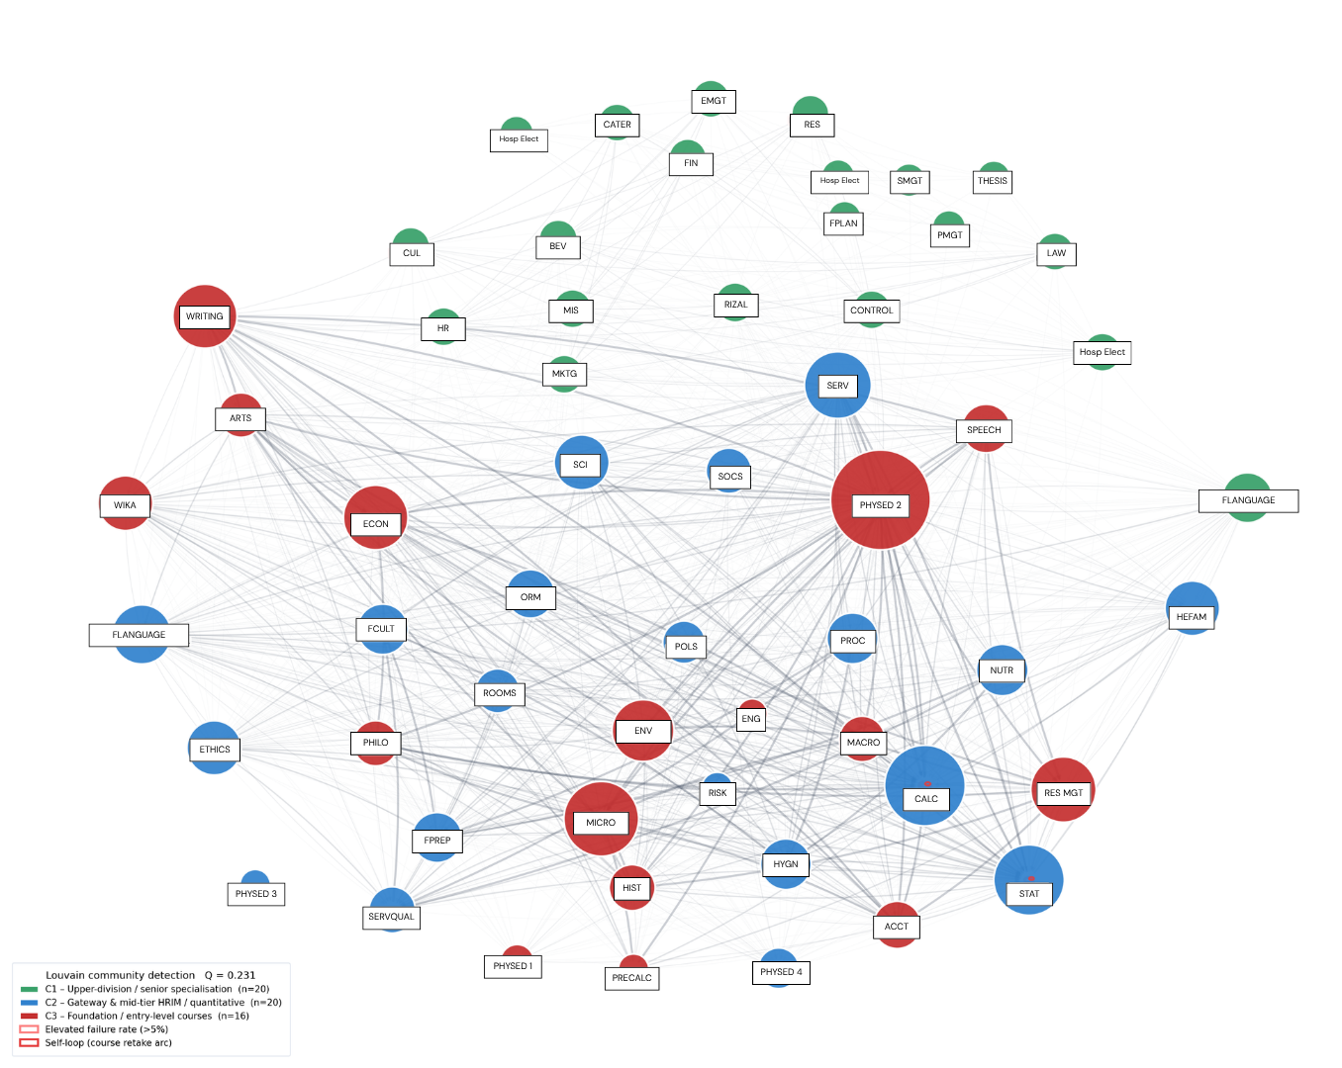
Note. Nodes represent courses as actually enrolled in by students; directed edges connect sequentially enrolled courses across semesters, with only transitions of five or more student instances shown. Edge thickness proportional to transition frequency. Node color encodes Louvain community membership (Q = 0.231). Node size proportional to weighted in-degree. Red rings indicate a failure rate above 5%. Self-loops on CALC, STAT, and PHYSED2 indicate re-enrollment.

The network is organized into three structural layers, as shown in Figure 2. The color corresponds to these structural layers.

4.3.1. Layer 1: Foundational and General Education (Red)
These courses have a large out-degree relative to their in-degree, serving as launch pads that propel students into many subsequent courses. The dominant first-semester entries are MACRO (268 attempts, out-degree 1,069) and ACCT (273 attempts, out-degree 1,022). Other high-out-degree Layer 1 nodes include ARTS (out 1,012), HIST (out 957), PHILO (out 907), and SPEECH (out 904). PRECALC (115 attempts) is a non-credit bridge course; all recorded grades are P/F, INC, or DRP. ENG is the only pure source node (in-degree = 0, out-degree = 7).

4.3.2. Layer 2: Quantitative Bottleneck (Blue)
CALC is the most consequential bottleneck node. It recorded 295 attempts from 194 unique students, a 37.3% failure rate, an average grade of 3.56, and a self-loop weight of 71 with avg_grade_from = 4.94, confirming that nearly all retakers had failed previously. CALC holds the second-highest in-degree (1,181) and a very high out-degree (928). It is simultaneously a major destination and a major source of transitions.

STAT shows a parallel but less extreme pattern: 249 attempts from 212 students, a 13.2% failure rate, an average grade of 2.80, and a self-loop weight of 21 with avg_grade_from = 4.85. ECON is a general education subject with a moderate 4.9% failure rate across 185 attempts. ACCT is the only hospitality course with a non-trivial failure rate: 4.0% from 273 attempts, average grade 2.09, self-loop weight 11.

4.3.3. Layer 3: Hospitality Majors Convergence Sink (Green)
Once students clear the quantitative bottleneck, the network converges toward a dense cluster of hospitality subjects. MICRO receives the highest in-degree of any non-PHYSED node at 1,106. Its 0.0% failure rate and average grade of 1.35 indicate that students who reach MICRO perform exceptionally well. Downstream, the network fans out into core hospitality courses, all with 0.0% failure rates and grades clustering between 1.0 and 1.7: ORM (138 students, avg 1.69), SERVQUAL (148, avg 1.25), NUTR, FCULT, PROC, ROOMS (84–87 students, avg 1.36–1.52), and other courses (0.0–0.6% failure). PRACTICUM is the terminal course; 15 students are currently enrolled.

Figure 3.
Hospitality Student Progression Flow (N = 269)
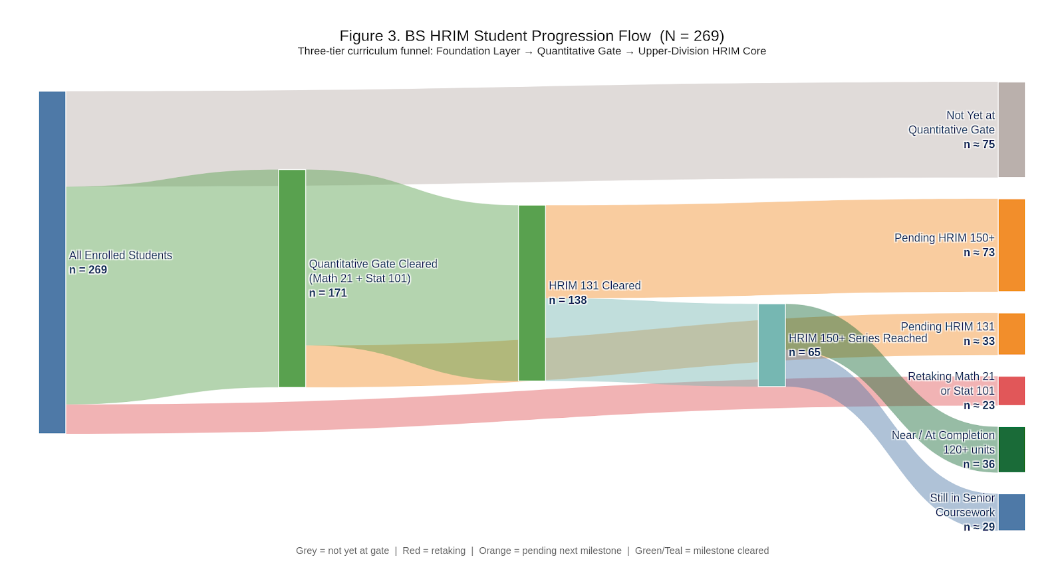
Note. The three-tier curriculum funnel from enrollment, through the quantitative gate, to upper-division hospitality coursework and near completion. Grey = not yet at quantitative gate (n ≈ 75); Red = retaking CALC or STAT (n ≈ 23); Orange = pending next milestone; Green/Teal = milestone cleared.

The Sankey diagram in Figure 3 visualizes how 269 hospitality students progress through a three-tier funnel: from all enrolled students, through the quantitative gate (CALC + STAT), to OR, then to the CUL+ series, and finally to near completion. It highlights three key flows: students not yet at the quantitative gate; students stuck in quantitative retakes (CALC/STAT); and students who have cleared ORM and are either pending CUL+ or already near/at completion. The width of each stream makes clear that the largest losses and delays occur at the quantitative gate and just before CUL+, not in the upper-division core itself.

4.4. Comparative Network Parameters
Table 8 presents computed graph-theoretic parameters for both networks side by side. The contrast between the two columns is the quantitative signature of the gap between curriculum design and actual student navigation.

Table 8.
Comparative Network Parameters—Structural vs. Empirical Networks
Parameter | Structural | Empirical
Nodes (N) | 49 | 56
Edges (excl. self-loops) | 36 | 1,621
Self-loop edges | 0 | 12
Graph density | 0.015 | 0.526
Average degree (in = out) | 0.74 | 28.95
Max in-degree | 3 | 55
Max out-degree | 8 | 53
Weakly connected components | 13 | 1
Strongly connected components | 49 | 2
Largest WCC node count | 31 | 56
Avg shortest path (largest WCC) | 3.135 | 1.358
Network diameter (largest WCC) | 6 | 2
Avg clustering coefficient | 0.000 | 0.807
Reciprocity | 0.000 | 0.780
Is DAG? | Yes | No
Longest prereq path (edges) | 4 | —
Source nodes (in-deg = 0) | 16 | 1
Sink nodes (out-deg = 0) | 28 | 0
Louvain communities | 9 | 3
Modularity Q | 0.674 | 0.231
Note. Density = E / [N(N−1)]. Shortest path and diameter are computed on the undirected projection of the largest weakly connected component. The node-count difference (49 vs. 56) arises because the empirical network includes elective variants and alternative-slot choices that appear in student records but not in the prerequisite graph. Weighted parameters: avg. weighted degree = 408.4; max weighted in-degree = 1,541 (PHYSED 2); max weighted out-degree = 1,679 (PHYSED 2).

Density exhibits the starkest contrast: the structural network’s 0.015 indicates only 1.5% of potential directed links are official prerequisites, whereas the empirical network’s 0.526 shows over half of possible transitions are observed, a 35-fold difference reflecting students’ behaviors like enrolling in multiple courses simultaneously, repeating failed ones, and taking optional courses in flexible sequences—connections not prescribed by the curriculum.

Degree statistics reinforce this: the structural network’s average degree of 0.74 suggests most courses have fewer than one prerequisite or dependent, consistent with a sparse prerequisite tree, while the empirical network’s average degree of 28.95 shows each course connected to nearly every other through observed transitions, with a maximum in-degree of 3 (ORM) versus 55 (PHYSED 2). Shortest path length decreases from 3.14 to 1.36, and diameter from 6 to 2, reflecting that nearly any two courses are directly connected or separated by one course in the empirical network. Clustering coefficient and reciprocity are zero in the structural network but high (0.807 and 0.780) in the empirical network, indicating co-enrollment and students moving back and forth across semesters. Modularity drops from 0.674 to 0.231, indicating blurred community boundaries and suggesting increased curriculum friction, in which students cycle through lower-level courses rather than progressing.

4.5. Self-Loops (Retake Patterns)
Twelve courses generated self-loop edges, meaning students returned to take the same course in a later semester. The pattern is clear: CALC and STAT generate mandatory failure-retake loops (average entry grade near 5.0), while PHYSED2 generates self-loops because it must be taken 4 times.

4.6. Curriculum Flexibility
The checklist includes several slash-alternative slots in which students satisfy a requirement by choosing one of two or more designated courses. Zuev & Stavrinides (2025) distinguish between conjunctive prerequisites (all required) and disjunctive prerequisites (one of several alternatives). The hospitality slash alternatives are disjunctive; each was parsed separately and treated as a distinct node reflecting actual enrollment.

Among the observed choices, SOCS attracted 100 students, compared with 77 for POLS. SCI was the overwhelming choice (191 students), compared with RISK (7 students), reflecting disparities in section availability. Hospitality electives follow a strict sequential pattern (Elective 1 → 2 → 3). A cohort of off-season students took an elective ahead of schedule but could not progress to the CUL series due to prerequisite restrictions—specifically, failure to pass Math 21 on time. RIZAL (Life and Works of Jose Rizal), mandated by Republic Act No. 1425, has been completed by 59 students with a 0.0% failure rate. Overall, the limited flexibility of alternatives offers few options for students stuck at quantitative bottlenecks.

5. Discussion and Implications

5.1. Discussion
The weighted dual-network analysis reveals a three-tier curriculum funnel: a broad general education and introductory hospitality foundation layer that co-enrolls with dozens of courses and generates dense early-semester transitions; a quantitative bottleneck (CALC and STAT) that acts as a filter before OR; and a tightly convergent upper-division core anchored by MICRO (in-degree 1,106, 0.0% failure rate), flowing into specialization courses and the terminal practicum cluster.

This three-tier structure maps onto the flux profile of Zuev & Stavrinides (2025). Layer 1 corresponds to positive-flux strata that emit more prerequisite links downstream than they receive—the curriculum’s knowledge-injection layer. Layer 2 represents the peak-flux stratum, where the prerequisite concentration is highest, and failure has the most downstream consequences. Layer 3 corresponds to negative-flux strata that consume many prerequisites while producing few—the terminal knowledge-absorption phase. This flux interpretation elevates the three-tier model from descriptive observation to theoretical characterization.
CALC’s downstream impact is best understood through the reach metric (Yang et al., 2024). CALC is an indirect prerequisite to the entire CUL series and all subsequent major courses. Any student who fails faces two consequences: delay in that single course and effective lockout from a large portion of their degree for at least one additional semester. Yang et al. found introductory mathematics bottlenecks most severe at the largest institutions. The data we find fit this pattern precisely, strengthening the generalizability of the hospitality findings across different national and institutional contexts.

The most actionable signal is the CALC bottleneck. Targeted early intervention—tutoring support and curricular scaffolding with Math 20—is the highest-leverage action. Another option is to allow students who failed CALC to take ORM concurrently, with both courses required before they can progress to the CUL series. Without this change, the CALC self-loop continues indefinitely. All courses above MICRO have zero failures, suggesting that once students clear the quantitative prerequisites, they are well prepared to complete their major requirements.

The comparative network analysis (Table 8) provides macro-level quantification of curriculum friction. The modularity gap (0.674 vs. 0.231) reveals a design-reality gap: the curriculum is designed as well-partitioned communities, but student progression blurs these boundaries as failing students cycle back through lower-tier courses. The 35-fold density contrast (0.015 vs. 0.526) confirms that students are not following the prescribed linear path, largely due to the CALC/STAT bottleneck, which is forcing a reorganization of the schedule.

We emphasize that network positions and failure rates identify structurally high‑risk locations rather than prove causality; structural risk (high reach, blocking factor) and performance risk (high failure rates) should be read together, and any causal claims would require additional qualitative work and predictive modeling using prior grades or entry scores.

5.2. Institutional Resource Impact of the CALC Bottleneck
The third research objective was to quantify the impacts of failure rates on institutional resources and student progress. Of the 194 students who have attempted CALC, only 171 have passed, leaving 23 students (11.9%) caught in mandatory retake cycles. The self-loop weight of 71 means CALC has consumed approximately 71 additional student-semester enrollment slots beyond its expected first-attempt load.

The downstream cascade is severe. Each failed attempt at CALC delays access to 16 downstream courses (reach = 17, including ORM itself) by at least one semester. ORM has been offered every semester since 2022—twice per year rather than once—specifically to accommodate students delayed by failures in CALC and STAT. This constitutes at least three additional off-schedule section offerings over four academic years, each requiring faculty allocation, classroom assignment, and administrative scheduling outside the standard calendar.

With enrollment nearly quadrupling between 2021 and 2025, this structural pressure is not temporary but a recurring cost embedded in the current prerequisite architecture. The network analysis confirms that no alternative pathway exists: CALC has a blocking factor of 1 and a reach of 17, with no redundant route bypassing this chokepoint.

The universality of this pattern is supported by Yang et al. (2024), who found introductory mathematics courses achieved the highest betweenness centrality and reach values across all six institutional CPNs studied, from CalTech’s 771-node network to UIUC’s 5,126-node network. The hospitality finding extends this structural regularity to a non-STEM, service-sector professional program in the ASEAN region. In Zuev & Stavrinides’s (2025) flux framework, the stratum containing CALC would exhibit anomalously high positive flux—it emits far more prerequisite links downstream than it receives—making it the most consequential leverage point for curricular intervention.

5.3. Academic and Practical Implications
This study will inform curriculum review and future revisions. It aligns with ASEAN University Network Quality Assurance (AUN-QA) standards, under which the program was certified in 2023. These findings are actionable and consistent with Basavaraj et al. (2022), who demonstrated that network-based curricular analytics inform academic advising strategies by identifying which courses require additional support and which student sub-populations need targeted intervention.

For the said hospitality program, this translates to actionable advising protocols. Flag students who have not cleared CALC or STAT by the end of their second semester. These students are at elevated risk of multi-semester delays. Early and proactive advising prevents the prerequisite trap from compounding.

5.4. Limitations and Suggestions for Future Research
This study has important limitations. It is limited to a single institution and includes only currently enrolled students. Graduates and students who have left the program were excluded, introducing survivorship bias. Students who attempted CALC multiple times and ultimately withdrew are not represented in the N = 269 dataset. All reported course-level failure rates are therefore conservative lower-bound estimates; the actual proportion unable to clear the quantitative bottleneck is likely higher.
Future research should incorporate full cohort records, including withdrawn students, to obtain unbiased estimates of attrition. Qualitative interviews with students who dropped or failed would illuminate root causes—academic difficulty, scheduling conflicts, or both. Comparative studies with other hospitality curricula or hospitality management programs in the Philippines and broader ASEAN region would help determine whether this bottleneck is institution-specific or reflects systemic patterns in hospitality education.

6. Conclusion
This dual-network analysis reveals a substantial design–reality gap between the sparse, hierarchical prerequisite structure of the hospitality curriculum and the dense, highly clustered empirical progression network generated by actual student trajectories. In particular, CALC and ORM form a quantitative gate that concentrates structural and performance risk and amplifies delays for large cohorts.

For practitioners and policymakers, the main implications are to (1) prioritize early support and capacity planning for quantitative gatekeeping courses, (2) review the reliance on a single, linear quantitative chain in light of hospitality competency and accreditation frameworks, and (3) adopt curriculum network analytics as a routine tool for monitoring progression and evaluating proposed reforms before full-scale implementation.

References

Aldrich, P. R. (2015). The curriculum prerequisite network: Modeling the curriculum as a complex system. Biochemistry and Molecular Biology Education, 43(3), 168–180. https://doi.org/10.1002/bmb.20861

Basavaraj, P., Garibay, I., & Ozmen Garibay, O. (2022). Pathway patterns mobility study of first time vs. Transfer students in computer science and information technology programs at a public university. Journal of Applied Research in Higher Education, 14(2), 784–807. https://doi.org/10.1108/JARHE-12-2020-0429

Blondel, V. D., Guillaume, J.-L., Lambiotte, R., & Lefebvre, E. (2008). Fast unfolding of communities in large networks. Journal of Statistical Mechanics: Theory and Experiment, 2008(10), P10008. https://doi.org/10.1088/1742-5468/2008/10/P10008

Conijn, R., Snijders, C., Kleingeld, A., & Matzat, U. (2017). Predicting Student Performance from LMS Data: A Comparison of 17 Blended Courses Using Moodle LMS. IEEE Transactions on Learning Technologies, 10(1), 17–29. https://doi.org/10.1109/TLT.2016.2616312

Cullen, T. P., & Lambert, C. U. (1987). Teaching Quantitative Decision Skills in a Hospitality Curriculum. Cornell Hotel and Restaurant Administration Quarterly, 28(2), 42–45. https://doi.org/10.1177/001088048702800215

EDCOM 2. (2026, February 14). CHED curriculum updates take 11 years on average. EDCOM 2. https://edcom2.gov.ph/ched-curriculum-updates-take-11-years-on-average/

Fei, A., Chen, J., Lee, W., Xin, K., Behnke, C., & Gordon, S. (2025). Designing Hospitality Curriculum for the Future: A Comprehensive Assessment of an Undergraduate Program in the United States. Journal of Hospitality & Tourism Education, 37(2), 138–153. https://doi.org/10.1080/10963758.2025.2453736

Hagberg, A. A., Schult, D. A., & Swart, P. J. (2008). Exploring Network Structure, Dynamics, and Function using NetworkX. 11–15. https://doi.org/10.25080/TCWV9851

Heileman, G. L., Thompson-Arjona, W. G., Abar, O., & Free, H. W. (2019, June 15). Does Curricular Complexity Imply Program Quality? 2019 ASEE Annual Conference & Exposition. https://peer.asee.org/does-curricular-complexity-imply-program-quality

Jacomy, M., Venturini, T., Heymann, S., & Bastian, M. (2014). ForceAtlas2, a Continuous Graph Layout Algorithm for Handy Network Visualization Designed for the Gephi Software. PLoS ONE, 9(6), e98679. https://doi.org/10.1371/journal.pone.0098679

Newman, M. E. J., & Girvan, M. (2004). Finding and evaluating community structure in networks. Physical Review E, 69(2), 026113. https://doi.org/10.1103/PhysRevE.69.026113

Rienties, B., & Toetenel, L. (2016). The impact of learning design on student behaviour, satisfaction and performance: A cross-institutional comparison across 151 modules. Computers in Human Behavior, 60, 333–341. https://doi.org/10.1016/j.chb.2016.02.074

Roxas, R. M., & Tapang, G. (2010). Prose and poetry classification and boundary detection using word adjacency network analysis. International Journal of Modern Physics C, 21(04), 503–512.

Slim, A., Heileman, G. L., Kozlick, J., & Abdallah, C. T. (2014). Predicting student success based on prior performance. 2014 IEEE Symposium on Computational Intelligence and Data Mining (CIDM), 410–415. https://doi.org/10.1109/CIDM.2014.7008697

Wang, J., & Abukhalifeh, A. N. M. (2021). Evaluating Undergraduate Curriculum in Hospitality Management: A Comparison between China and South Korea. Journal of China Tourism Research, 17(4), 613–633. https://doi.org/10.1080/19388160.2020.1788684

Yang, B., Gharebhaygloo, M., Rondi, H. R., Hortis, E., Lostalo, E. Z., Huang, X., & Ercal, G. (2024). Comparative analysis of course prerequisite networks for five Midwestern public institutions. Applied Network Science, 9(1), 25. https://doi.org/10.1007/s41109-024-00637-z

Zuev, K. M., & Stavrinides, P. (2025). Breadth, depth, and flux of course-prerequisite networks. Network Science, 13, e17. https://doi.org/10.1017/nws.2025.10013

